Screenshots of Execution for O(N log N)

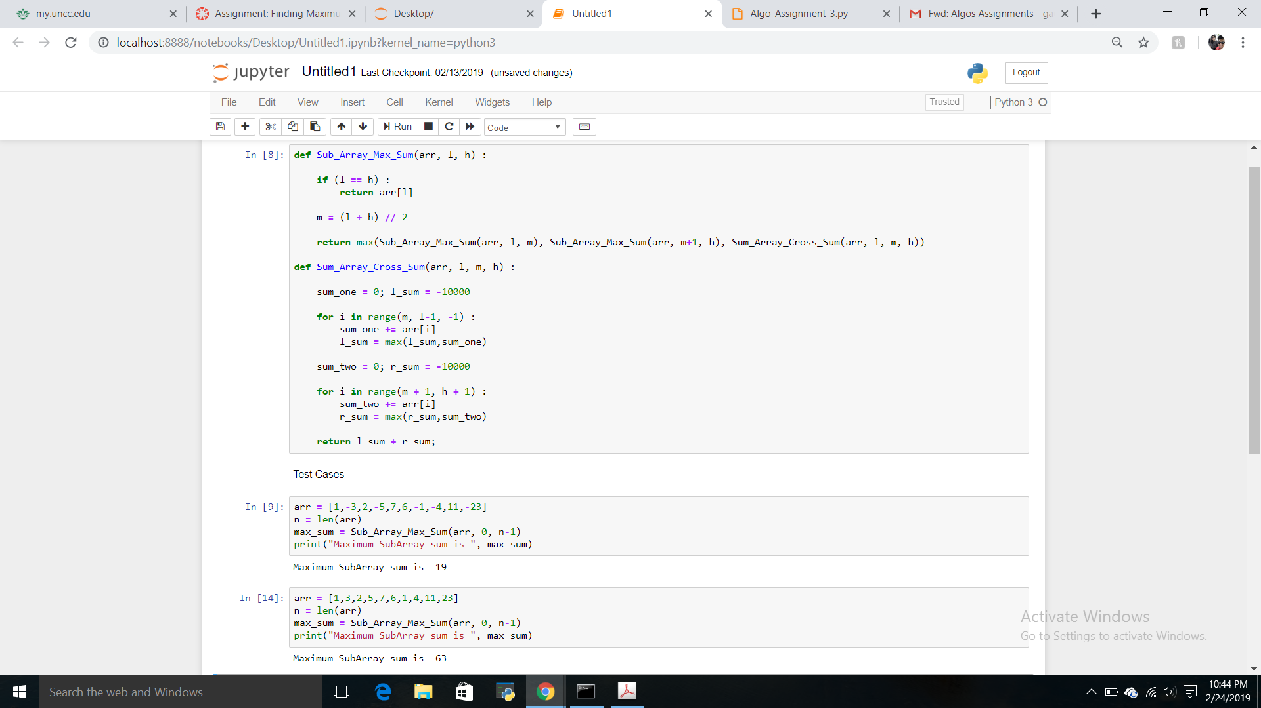

Extra Credit

Correctness Analysis for O(N log N)

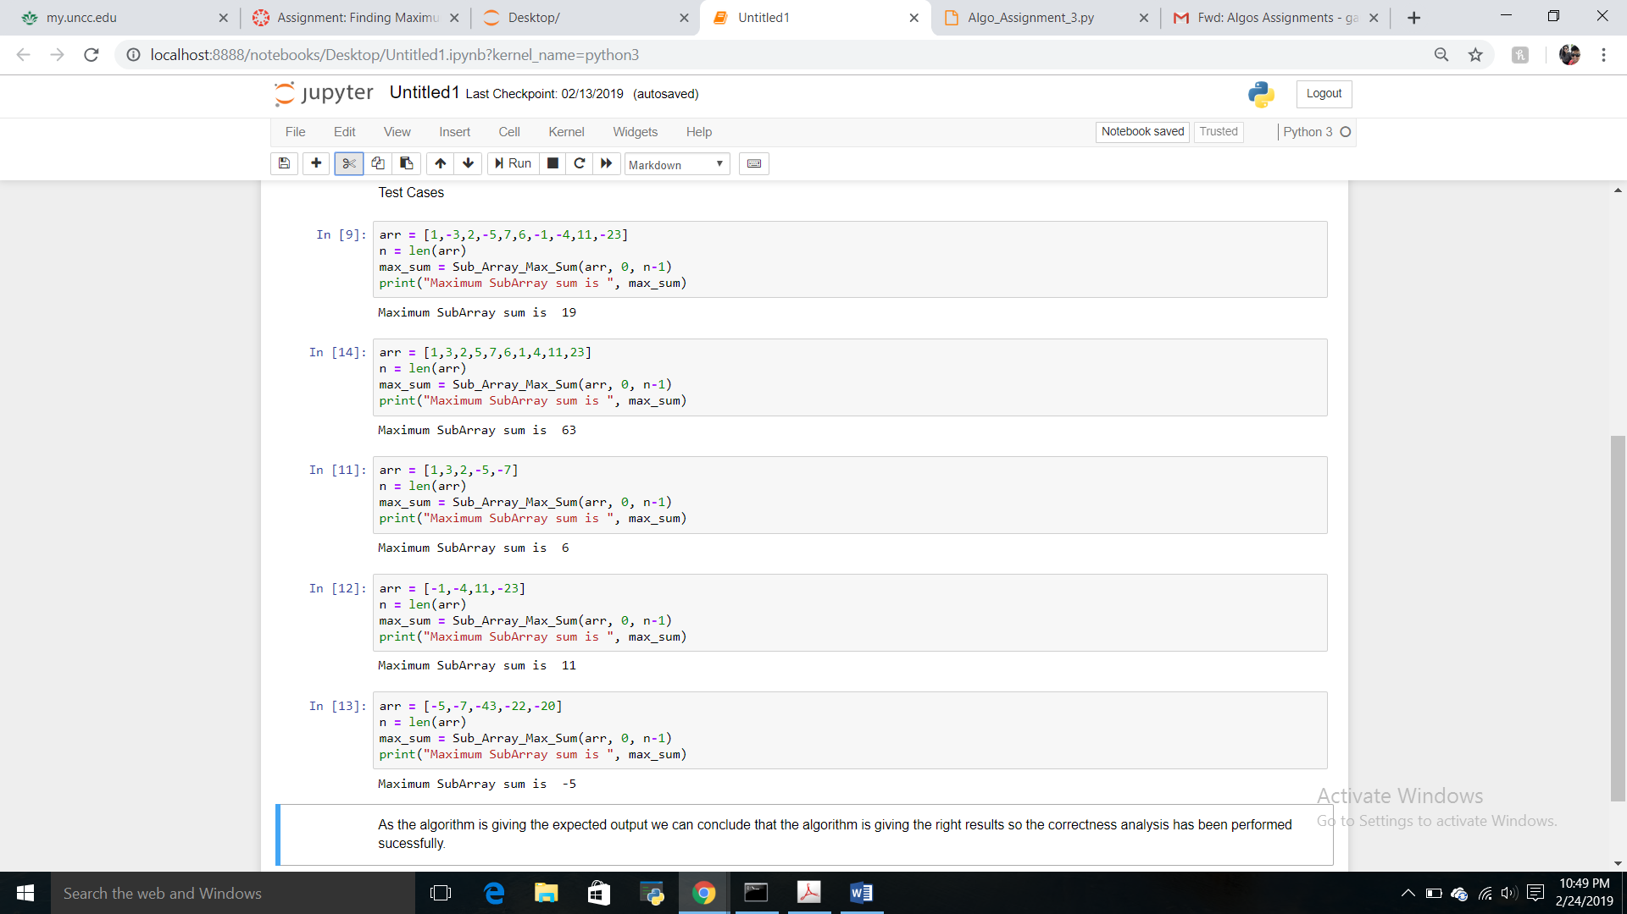

Screenshots of Execution for O(N)

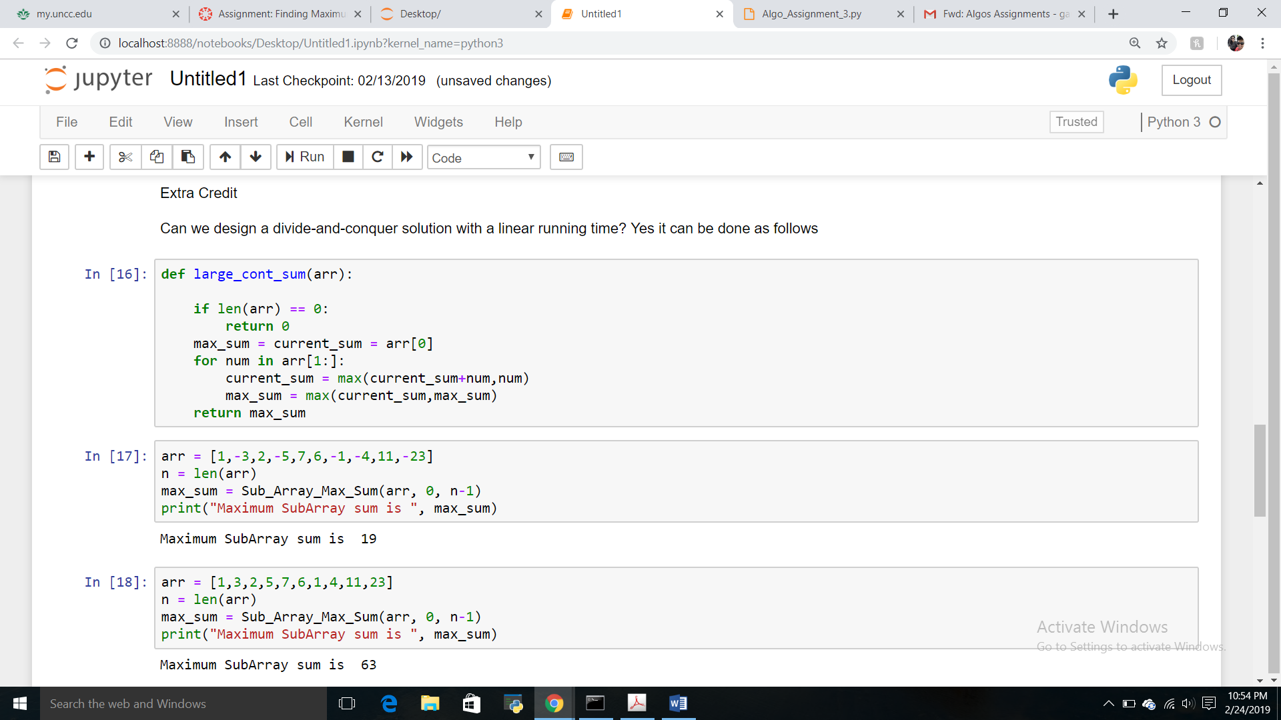

Correctness Analysis for O(N)

